Insurance Claims Cost Analysis
Using Linear Regression in R
Project Report

Submitted by: Shaurya Kapoor
Course: B.Sc. (Hons.) Statistics
College: Ramjas College
University of Delhi
Academic Session: 2025–26

Insurance Claims Cost Analysis Using Linear Regression in R

- INTRODUCTION
Insurance companies estimate medical claims cost using information like age, BMI, Smoking status, number of children and region. Predicting these costs helps insurance company’s providers understand the risk and make better pricing decisions. In this project, linear regression techniques were used in R language to analyze the insurance dataset and predict medical charges.

- OBJECTIVE
The main objective of this project was to develop a machine learning model using linear regression in R to predict insurance charges based on customer information such as age, BMI, smoking status, number of children, sex and region. Another objective was to understand how these factors influence medical insurance costs through exploratory data analysis, data visualization and correlation analysis. This project also aimed to gain practical experience in data preprocessing, regression modelling, model evaluation and interpreting results using real-world data.

- DATASET DESCRIPTION
The dataset used in this project contains the information about the individuals and their medical insurance charges. It includes both demographic and health related attributes that may influence the overall cost of insurance. The dataset was imported into R using the readr package and carefully examined before performing any analysis.
The main variables available in the dataset are:
- Age – age of the policyholder
- Sex – Gender of the individual
- BMI (Body Mass Index) – A measure of body weight relative to height
- Children – Number of dependent children covered by the Insurance
- Smoker – Indicates whether the individual is a smoker or a non-smoker
- Region – Residential region of the policyholder
- Charges – Medical insurance charges, which is the target variable for prediction
These variables were used to understand how personal and lifestyle factors affect the insurance costs.

- DATA EXPLORATION

Before building any predictive model, the dataset was explored to understand its structure and quality. Functions such as head (), str () and summary () were used to examine the observations, data types and summary statistics of each variable
A missing value check was also done using is.na (), and no missing values were found in the dataset,
To gain better insights into the data, different visualizations were created:
- Histogram of Age to observe the age distribution
- Histogram of BMI to understand the spread of body mass index
- Boxplot of Insurance Charges by smoking Status
- Scatterplot of BMI versus Insurance Charges along with a regression line to examine the relationship between BMI and insurance expenses.
These visualizations helped identify important trends and patterns before developing the regression models.

FIGURE 1: Distribution of Age
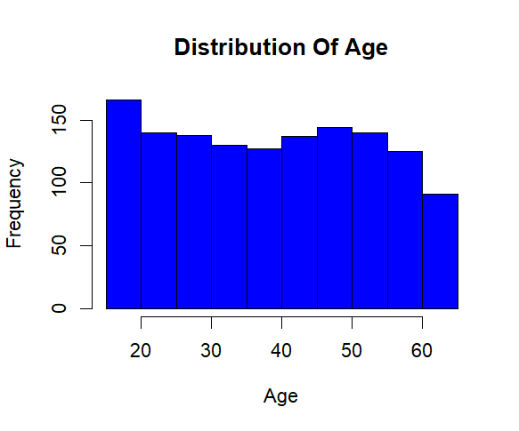
FIGURE 2: Distribution of BMI
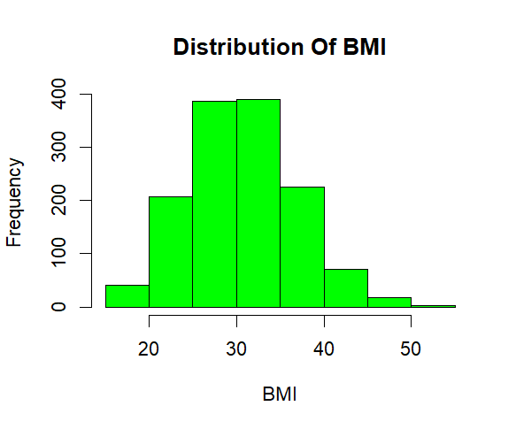
FIGURE 3: Boxplot of Insurance Charges by smoking Status
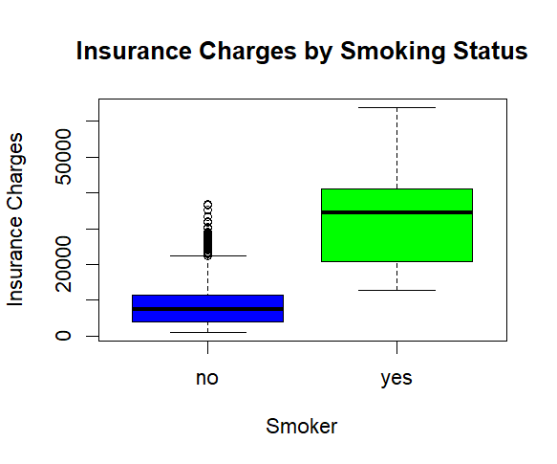
FIGURE 4: BMI vs INSURANCE CHARGES
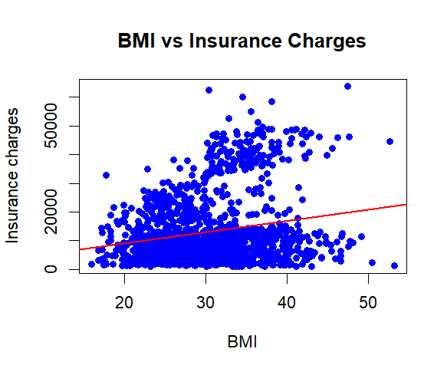
FIGURE 5: CORRELATION HEATMAP
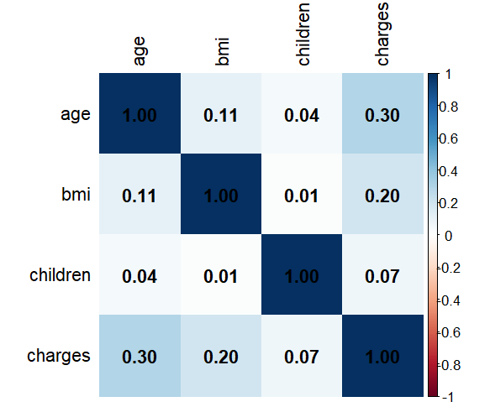

- REGRESSION ANALYSIS
Linear regression techniques were used to predict insurance charges based on the available variables.
Initially, a simple Linear Regression model was created using BMI as the only predictor variable. This helped to understand the direct relationship between BMI and insurance charges.
Afterwards, a Multiple Linear Regression model was developed by including Age, BMI, Smoking Status, Number of Children, Sex and Region as predictor variables. Using multiple variables together improved the model’s ability to explain variations in Insurance charges and produced more accurate predictions.
The regression summaries were analyzed to understand the significance and contribution of each predictor.
- FEATURE IMPORTANCE AND CORRELATION
To understand the influence of different variables, the regression coefficients were extracted from the multiple regression model and displayed using a feature importance bar chart. This visualization made it easier to compare the impact of different predictors on insurance charges.
A correlation matrix was also generated for the numerical variables, followed by a correlation heatmap using the corrplot package. The heatmap provided a clear visual representation of the relationships between Age, BMI, Number of Children and Insurance Charges.
These analyses helped identify variables that were more strongly associated with insurance costs.

- MODEL EVALUATION
After training the multiple regression model, insurance charges were predicted for each observation in the dataset. The predicted values were then compared with actual insurance charges using a scatterplot.
To evaluate the performance of the model, two commonly used metrics were calculated
- $R^{2}$= 0.75
- $RMSE=6042$(approx.)
An $R^{2}$ value of approximately 0.75 indicates that the model is able to explain nearly 75% of the variation in insurance charges, suggesting a reasonably good fit.
The RMSE value of approximately 6042 represents the average prediction error of the model. Although some predictions error exists, the model provides satisfactory performance for understanding and estimating insurance charges.

- CONCLUSION
The project successfully demonstrated the application of linear regression techniques for predicting medical insurance charges using our language. The complete workflow included data loaded, exploratory data analysis, visualization, correlation analysis, regression modelling and model evaluation.
The analysis showed that variables such as Smoking Status, Age and BMI have a significant influence on insurance charges. Compared to the simple regression model, the multiple linear regression model produces more reliable and accurate predictions by considering several variables simultaneously.
Overall, this project strengthened my practical understanding of data analysis, statistical modelling and predictive analytics using R. It also provided valuable hands-on-experience in working with real-world datasets and interpreting the results of predictive linear regression model.

